Type II Diabetes

### A compartmental model for evaluation of glucose, glucagon, and insulin dynamics.

Group 8: Chloe Gonterman, Jake Peters, Rachel Surridge

A Compartment Model for Evaluation of Glucose, Glucagon, and Insulin Dynamics

### 

### 

# 

**Introduction** **4**

Diabetes Background 4

Healthy Blood Sugar Control 4

Effect of Diabetes on Blood Sugar Control 4

Control Systems Background 5

Sorensen Model 7

**Plant Overview** **8**

Nomenclature 8

The Glucose Subsystem 10

Glucose Subsystem Equations 11

Glucose Subsystem Inputs and Outputs 14

The Insulin Subsystem 15

Insulin Subsystem Equations 16

Insulin Subsystem Inputs and Outputs 17

The Glucagon Subsystem 18

Glucagon Subsystem Equations 18

Glucagon Subsystem Inputs and Outputs 18

The Pancreas Subsystem 19

Pancreas Subsystem Equations 19

Pancreas Subsystem Inputs and Outputs 20

Modeling T2 Diabetes 21

**Plant Implementation** **22**

General Implementation Methods 22

Implementation Challenges 23

Boot-Up Response 23

Artificial Insulin Pump Integration 26

Glucose Disturbance Infusion 27

Transfer Function Approximation 28

Controller Creation and Tuning 30

**System Characterization** **35**

Disturbance Waveforms 36

System Response to IGTT Data 37

System Response to Square Wave 40

System Response to Shallow Disturbance 44

**Conclusion** **48**

**Sources** **48**

**Appendix** **50**

Appendix A: Constants 50

Appendix B: Code 51

Step Input Characterization and Transfer Function Fitting 51

Basal Values (From Vahidi) 52

Constant Values (From Vahidi) 54

# 

# 

# 

# 

This page intentionally left blank.

# 

# 

# 

# 

# 

# 

# 

# Introduction

Type II diabetes is a prevalent disease in the United States. Over 30 million people are type II diabetic, 84 million people are pre-diabetic, and it is the 7th leading cause of death in the country [1, 2]. The unfortunate, yet important role that type II diabetes has on the lives of those living in the United States validates the research done and model created for this project. The implementation of type II diabetes into a compartmental model that can be regulated using a proportional controller shows how closed system insulin pumps could be used in the future, for both type I and type II diabetes.

## Diabetes Background

Diabetes is a disease that inhibits the body’s ability to regulate blood sugar levels. Blood sugar is normally controlled by the following process.

### Healthy Blood Sugar Control

In a healthy system, blood sugar levels are able to be controlled by the pancreas. Blood sugar levels are altered when a person ingests carbohydrates. During digestion, carbohydrates are broken down into glucose. Increased glucose results in an increase in blood sugar level [3]. When the blood sugar level is high, the pancreas will secrete insulin. Insulin is made in pancreatic beta cells [3]. The insulin travels through the blood and binds to its specific receptors on tissue cells throughout the body. The binding to the receptor triggers the cells to open up gates to collect glucose from the blood. If there is extra glucose in the body, insulin will also stimulate the liver to facilitate the conversion of glucose into glycogen for use later on when needed. When the blood sugar level is low, the pancreas will secrete glucagon, which is made in pancreatic alpha cells. Glucagon triggers hunger in the person, and stimulates the breakdown of glycogen back into glucose to be used by tissue cells [3].

### Effect of Diabetes on Blood Sugar Control

There are two forms of diabetes that inhibit the normal ability of the body to maintain healthy blood sugar levels: Type I and Type II. Type I diabetes is a genetic, autoimmune disorder where the body’s immune system breaks down beta cells in the pancreas [4]. Without beta cells, insulin cannot be made or secreted, and tissue cells will not know to uptake glucose from the blood. Type I diabetic patients require insulin injections in order to survive. Type II diabetes is different from type I because it is developed over time and is due to a person’s lifestyle [5]. The disease comes about when the pancreas cannot secrete enough insulin to maintain a normal blood sugar level. The pancreas’s inability to keep up with regulating blood sugar level initially occurs because the person is intaking too much sugar, so the pancreas is always having to secrete insulin. After continuously secreting high levels of insulin, the beta cells making insulin begin to burn out from being overworked [5]. Once they are burnt out the insulin production decreases, and if the person continues to consume large amounts of sugar, then health concerns can arise because glucose will remain in the bloodstream.

That being said, type II diabetes can be controlled by lifestyle changes [5]. Diet and exercise can decrease the amount of sugar entering the bloodstream and increase the cells need to make energy from glucose, respectfully. If it is caught and managed before too much damage is done to the pancreas, type II diabetes can be reversed. If not, then the person’s type II diabetes can escalate to be so severe that it is similar to type I diabetes. In that situation, insulin injections, and/or other medications may be needed for the type II diabetes patient.

Physicians and researchers are working to find ways to make sure type II diabetics do not escalate to become insulin injection dependent. A way to stop that escalation is finding a way to offload the pancreas so it does not burn out from insulin overproduction. Currently, research on the effects that type II diabetes has on different body organs is of interest because it can create patient specific treatment methods. These treatment methods can aid in stopping the escalation of type II diabetics from becoming completely insulin dependent.

The Sorensen Model is an existing model that compartmentalizes organs into individual systems within the body in order to model type II diabetes. Before an introduction to the Sorensen Model is given, control systems background will be presented.

## Control Systems Background

The proverbial gold standard of diabetes care would be a closed loop system with a controlled output from an insulin pump. That being said, there are currently no FDA approved closed loop diabetes care systems. Instead diabetes care systems are open loop in which the user inputs the amount of insulin they need through pump instructions. This makes the disease very noticeable for the patient on a day to day basis. It would be very beneficial to create a system in which the user didn’t have to worry about their disease on a day to day basis. In this paper the aim is to create a model for controlling diabetes in a closed loop system making one large assumption. In Figure 1 below is the proposed control loop for a diabetes care system.

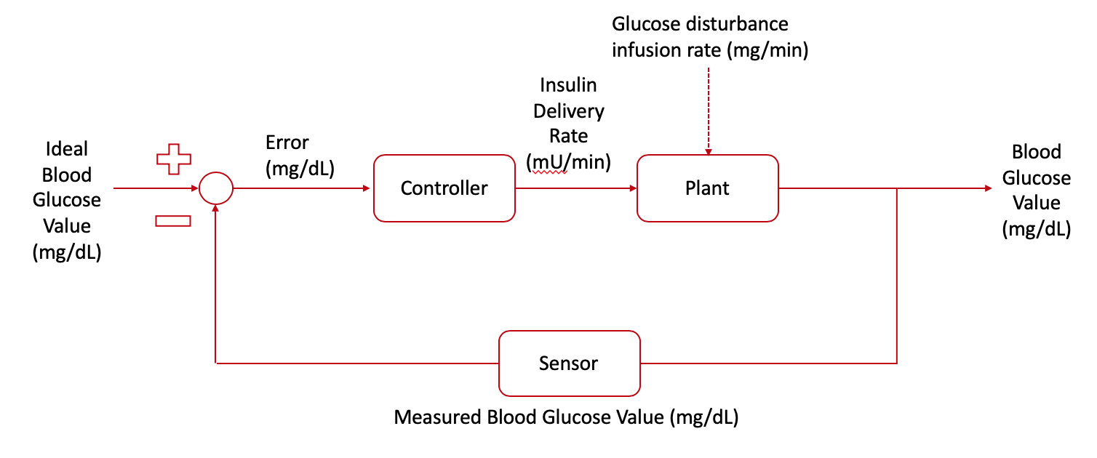

Figure 1: Proposed diagram for closed loop control of Diabetes using an insulin pump

As can be seen it has three standard components of a control loop. The equation governing a control loop is as follows [6].

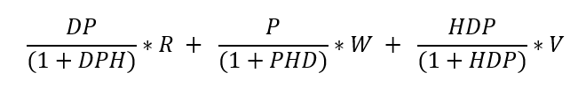

In this case R is a target blood glucose value of 120 mg/dl. W is a disturbance in the form of a glucose infusion rate measured in (mg/min) and V is the error of the system interpreting the output which is the blood glucose value of the patient at any given time. In a lot of cases assuming an ideal sensor of unity gain (1) can greatly simplify the problem and eliminate sensor error. For this paper an ideal sensor value of one was assumed. The real sensor error is determined by the difficulty of the system to interpret the output of the blood glucose system. Nearly everything the body does affects how it uptakes blood glucose. Everything from small changes to very large ones. This makes building a sensor to monitor blood glucose very difficult. The risk of building an improper sensor results in sensor error or a misinterpretation of the output from what the output really is. In small amounts this doesn’t pose a large threat to the system. In cases of large sensor error the result could be catastrophic. The sensor could either greatly underestimate the actual blood glucose value or overestimate the actual blood glucose value. In the first case the pump would compensate by not outputting insulin while the in the second case the pump would compensate by over pumping insulin. Both cases could potentially result in death for the patient which can not be overstated.

By assuming a perfect sensor, the control problem becomes much easier and consists of only two components. The output of the system is interpreted perfectly and compared to the target blood glucose value and sent to the controller as an error value. The controller interprets the error and responds accordingly by admitting insulin to the plant. For the purpose of simplifying the control problem the system multiplies the error by negative one so that positive error equates to output of insulin. This paper aims to model the plant using a compartmental model to characterize blood glucose flow throughout the body. The next section of this paper discusses the creation of the plant followed by the controller setup.

## Sorensen Model

The Sorensen Model, created by J.T. Sorensen in 1985, uses a compartmental model to represent the role of glucose, insulin, and glucagon metabolism in diabetes [B]. The compartments each have mass-balance equations that allow for calculations regarding the capillary diffusion rates in the specific locations to be taken into consideration. The compartments and what they represent are as follow

1. Brain: central nervous system
2. Heart & Lungs: rapid mixing of heart, lungs, and arteries
3. Periphery: skeletal muscle and adipose tissue
4. GI Tract
5. Liver
6. Kidney

When making the model, Sorensen made a list of assumptions, and these assumptions are also used in this application. The assumptions neglect the effects of hormones (epinephrine, cortisol, growth hormone), do not acknowledge the effects of amino acids and fatty acids, and choose to use blood flow rates and capillary volumes that represent a 70kg adult male [7].

Along with having six different compartments, the Sorensen model breaks up into four different subsystems to mathematically represent the metabolism. These four subsystems are glucose, insulin, glucagon, and the pancreas [7].

For each compartment, there are equations to show the mass balance of insulin and glucose. There is one mass balance equation across the whole body for glucagon, and the pancreas subsystem is represented by a subset of mass balance equations across a storage and labile compartment. These equations are presented in the Plant Overview.

Equation and model analysis show how the subsystems relate to one another. The Sorensen model is a nonlinear model with interdependency between subsystems. For example, the glucose level in one compartment can affect the insulin level in another compartment. Interdependency of variable will be discussed further in the Plant Overview.

Using the Sorensen Model equations, healthy and diseased systems can be created in MATLAB and Simulink. After successful implementation of the model, a controller can be added to the system, allowing for continuous regulation of the blood glucose level in the system after a certain blood glucose disturbance via the injection of insulin to the plant. If the blood glucose level is higher than acceptable, then the controller signals an increased insulin introduction to the plant in order to regulate the system.

For this project, the Sorensen Model will be used to create the plant for the control system [7]. The following section will provide more information on the plant subsystems and how they relate to one another, as well as their role in blood glucose regulation.

# Plant Overview

All information is reiterated and/or derived from Vahidi, O. “Dynamic modeling of glucose metabolism for the assessment of type II diabetes mellitus.” [8]

## Nomenclature

Model variables in the glucose sub-model:

D Oral glucose amount (mg)

G Glucose concentration (mg/dL)

M Multiplier of metabolic rates (dimensionless)

Q Vascular blood flow rate (dL/min)

r Metabolic production or consumption rate (mg/min)

T Transcapillary diffusion time constant (min)

t time (min)

V Volume (dL)

Model variables in the insulin sub-model

I Insulin concentration (mU/L)

M Multiplier of metabolic rates (dimensionless)

m Labile insulin mass (U)

P Potentiator (dimensionless)

Q Vascular blood flow rate (L/min)

R Inhibitor (dimensionless)

r Metabolic production or consumption rate (mU/min)

S Insulin secretion rate (U/min)

T Transcapillary diffusion time constant (min)

t time (min)

V Volume (L)

X Glucose-enhanced excitation factor (dimensionless)

Y Intermediate variable (dimensionless)

Model variables in the glucagon sub-model

Г Normalized glucagon concentration (dimensionless)

M Multiplier of metabolic rates (dimensionless)

r Metabolic production of consumption rate (dL/min)

V Volume (dL)

t time (min)

First superscript

Г Glucagon

B Basal condition

G Glucose

I Insulin

Second superscript

∞ Final steady state value

Metabolic rate subscripts

BGU Brain glucose uptake

GGU Gut glucose uptake

HGP Hepatic glucose production

HGU Hepatic glucose uptake

KGE Kidney glucose excretion

KIC Kidney insulin clearance

LIC Liver insulin clearance

MГC Metabolic glucagon clearance

PГC Plasma glucagon clearance

PГR Pancreatic glucagon release

PGU Peripheral glucose uptake

PIC Peripheral insulin clearance

PIR Pancreatic insulin release

RBCU Red blood cell glucose uptake

First subscripts

A Hepatic artery

B Brain

G Gut

H Heart and lungs

L Liver

P Periphery

S Stomach

∞ Final steady state value

Second subscripts (if required)

C Capillary space

F Interstitial fluid space

## The Glucose Subsystem

The compartments featured in the glucose subsystem include the:

1. Brain
2. Heart & Lungs
3. GI Tract
4. Liver
5. Kidneys
6. Periphery

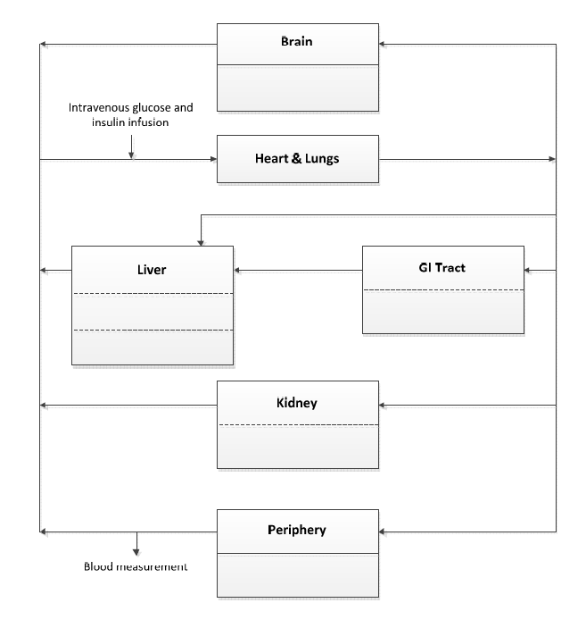

Figure 2: A diagram of the glucose subsystem [8].

The peripheral compartment represents the glucose metabolism of the muscles and adipose tissue and is split into a capillary blood space and an interstitial fluid space. The brain compartment is also sub-compartmentalized into a blood capillary space and an interstitial fluid space. All other compartments are considered to achieve fast equilibrium between the capillary blood space, interstitial fluid, and intracellular space. Thus, there are 8 governing equations for the glucose submodel (primary compartments (6) + sub-compartments (2)).

### Glucose Subsystem Equations

|  |  |
| --- | --- |
|  | 1 |
|  | 2 |
|  | 3 |
|  | 4 |
|  | 5 |
|  | 6 |
|  | 7 |
|  | 8 |

The rates present in Eq. 2, 3, 4, 5, 6, and 8 have the general form:

|  |  |
| --- | --- |
|  | 9 |

where is the basal metabolic rate, and the multipliers are rate modifiers that are dependent on glucose, insulin, and glucagon levels. They may also be time dependent. They have the general form:

|  |  |
| --- | --- |
|  | 10 |

where C is the concentration of insulin, glucagon, or glucose and CB is the baseline concentration.

|  |  |
| --- | --- |
|  | 11 |
|  | 12 |
|  | 13 |
|  | 14 |
|  | 15 |
|  | 16 |
|  | 17 |
|  | 18 |
|  | 19 |
|  | 20 |
|  | 21 |
|  | 22 |
|  | 23 |
|  | 24 |
|  | 25 |
|  | 26 |
|  | 27 |
|  | 28 |
|  | 29 |
|  | 30 |

### Glucose Subsystem Inputs and Outputs

The glucose subsystem receives three external inputs:

1. insulin concentration in the peripheral interstitial fluid space (, mU/L)
2. normalized glucagon concentration in the body (Γ, unitless)
3. insulin concentration in the liver (, mU/L)

It provides two outputs:

1. glucose concentration in the peripheral capillary space (BGV or , mg/dL)
2. glucose concentration in the heart (, mg/dL)

Insulin concentration in the peripheral interstitial fluid space is used to modulate the rate of peripheral glucose uptake (Equations 16, 18). Insulin concentration in the liver influences both hepatic glucose production and hepatic glucose uptake (Equations 21, 28). Glucagon influences hepatic glucose production. These relationships are described in Equations 23 and 24.

Peripheral capillary glucose concentration equates to a blood glucose value obtained by a typical finger-stick or subdermal continuous glucose monitor and is thus labeled blood-glucose value (BGV). This is the output of interest for the total, integrated model.

Glucose concentration in the heart space is utilized as an input by the pancreatic and glucagon sub-models.

## The Insulin Subsystem

The compartments in the insulin subsystem are the same as those used in the glucose subsystem, with the addition of the pancreas:

1. Brain
2. Heart & Lungs
3. GI Tract
4. Liver
5. Kidneys
6. Periphery
7. Pancreas

The compartment model representing this subsystem is displayed in Figure 3.

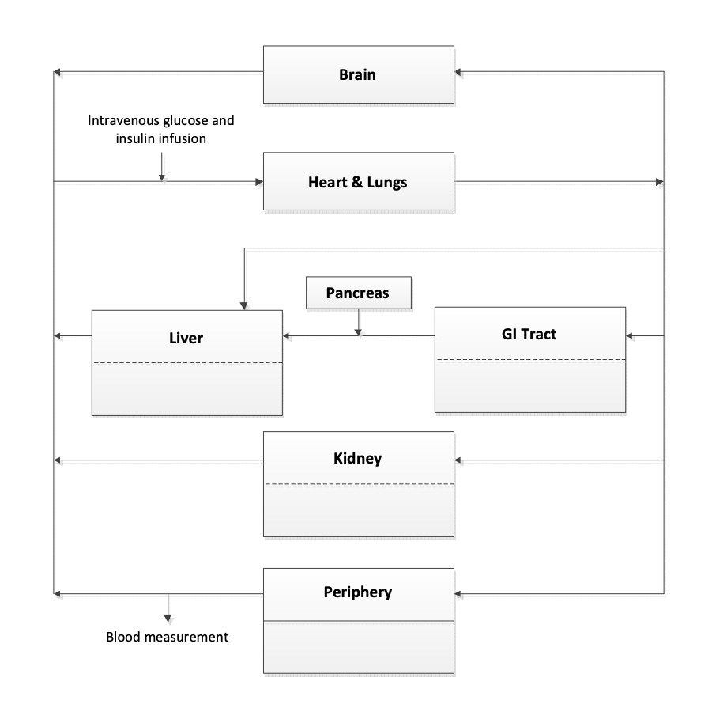

Figure 3: A diagram of the insulin subsystem [8].

The periphery compartment of the insulin subsystem is split into two parts to represent the muscles and adipose tissues. The assumption that equilibrium is quickly reached between the capillary blood space, interstitial fluid, and intracellular space is made for the brain, heart & lungs, pancreas, liver, GI tract, and kidney compartments. Due to these compartment breakdowns, there are 8 governing equations for this subsystem. The periphery has two, and the other compartments all have one. The governing equation for the pancreas will be presented in the Pancreas Subsystem section.

### Insulin Subsystem Equations

|  |  |
| --- | --- |
|  | 31 |
|  | 32 |
|  | 33 |
|  | 34 |
|  | 35 |
|  | 36 |
|  | 37 |
|  | 38 |
|  | 39 |
|  | 40 |

### Insulin Subsystem Inputs and Outputs

The insulin subsystem receives one external input:

1. Pancreatic insulin release rate (s or , mU/min)

It provides three outputs:

1. Insulin concentration in the peripheral interstitial fluid space (, mU/L)
2. Insulin concentration in the heart space (, mU/L)
3. Insulin concentration in the liver space (, mU/L)

Pancreatic insulin release rate is received from the pancreatic subsystem and integrated directly into the liver’s mass-balance equation, as described in Equation 34.

Insulin concentrations in the peripheral interstitial fluid space and the liver space are utilized by the glucose subsystem as previously mentioned.

Insulin in the heart space is utilized by the glucagon subsystem.

## The Glucagon Subsystem

The glucagon subsystem has only one mass balance equation for the whole subsystem (Equation 41). The rates in the equation are for the pancreatic glucagon release (Equation 43) and the plasma glucagon clearance (Equation 42). The glucagon volume in the blood is important because it is needed as an input to the nonlinear-glucose subsystem so that the correct peripheral blood glucose value and heart blood glucose value can be calculated.

### Glucagon Subsystem Equations

|  |  |
| --- | --- |
|  | 41 |
|  | 42 |
|  | 43 |
|  | 44 |
|  | 45 |
|  | 46 |

### Glucagon Subsystem Inputs and Outputs

The glucagon subsystem receives two external inputs:

1. Insulin concentration in the heart space (, mU/L)
2. Glucose concentration in the heart space (, mg/dL)

It provides a single output:

1. Normalized glucagon concentration (Γ, unitless)

Both glucose and insulin concentrations in the heart space are utilized to downregulate normalized glucagon concentration. This relationship is described by Equations 44 and 45.

## The Pancreas Subsystem

Insulin release from the pancreas is stimulated by blood glucose concentration changes. The model that Sorensen’s Model uses to represent pancreatic function by Landahl and Grodsky (Figure 4). The model shows the biphasic behavior of insulin secretion. P is the glucose stimulated factor that stimulates insulin release. The first phase of the biphasic behavior is insulin released due to a spike in a glucose-enhanced excitation factor (X) and then its inhibitor (R). The second phase is due to the dependence of insulin secretion (S) on the labile compartment filling factor (P).

### 

Figure 4: Model by Landahl and Grodsky to represent the insulin secretion from the pancreas [8].

### Pancreas Subsystem Equations

|  |  |
| --- | --- |
|  | 47 |
|  | 48 |
|  | 49 |
|  | 50 |
|  | 51 |
|  | 52 |
|  | 53 |
|  | 54 |

### Pancreas Subsystem Inputs and Outputs

The pancreatic subsystem receives one external input:

1. Glucose concentration in the heart space (, mg/dL)

It provides a single output:

1. Pancreatic insulin release rate (s or , mU/min)

Glucose concentration in the heart is received from the glucose subsystem and is used to calculate the instantaneous level of glucose-enhanced excitation factor X, which positively influences the rate of pancreatic insulin secretion. This relationship is described by Equation 54.

As previously mentioned, the pancreatic insulin release rate is directly integrated with the liver mass balance equation in the insulin subsystem.

## Modeling T2 Diabetes

Sorensen’s model was adjusted by Vahidi to model the glucose, glucagon, and insulin dynamics of a type 2 diabetic [8]. This was done via regression of model outputs against intravenous glucose tolerance test data obtained from 11 diabetic patients. Parameter modifications were limited to the following:

1. Insulin multiplier in peripheral glucose uptake rate (Eq. 16)
2. Insulin multiplier in hepatic glucose uptake rate (Eq. 28)
3. Insulin multiplier in hepatic glucose production rate (Eq. 21)
4. Glucose multiplier in hepatic glucose uptake rate (Eq. 29)
5. Glucose multiplier in peripheral glucose uptake rate (Eq. 17)
6. Pancreatic insulin secretion rates (N1 and N2) (Eq. 51)

For the purposes of this project, the results of optimization done by Vahidi were taken at face value and not repeated. Given the general form of the metabolic rate multiplier presented in Equation 10, the a, b, c, and d parameters were adjusted to the values in Table 1:

|  |  |  |  |  |
| --- | --- | --- | --- | --- |
|  | a | b | c | d |
|  | 2.551 | 1.66 | 0.69 | 3.454 |
|  | 1.173 | 1.073 | 0.993 | 1.164 |
|  | 0.662 | 0.731 | 0.985 | 0.493 |
|  | 1.855 | 1.85 | 2.047 | 1.244 |
|  | 0.897 | 0.103 | - | - |

is an exception to the general form, and instead has the form

55

N1 and N2 in Eq. 51 were adjusted to 0.00595 and 0.0467, respectively.

These modifications emulate key features of type II diabetes by modifying

1. Insulin resistance in the peripheral tissues
2. Insulin-induced stimulation of hepatic glucose uptake
3. Insulin-induced stimulation of hepatic glucose production
4. Glucose-induced stimulation of hepatic glucose uptake
5. Glucose-induced stimulation of peripheral glucose uptake
6. Pancreatic insulin secretion rate both in early peak and overall rate

# Plant Implementation

## General Implementation Methods

All equations were implemented in a Simulink model (.slx) using Simulink 9.3 (associated with MATLAB R2019a licenses). Continuous integrator blocks were used to model first order differential equations. Saturation-limited integrator blocks were used for all glucose, insulin, and glucagon mass-balance equations to ensure that masses/concentrations could not fall below zero. The upper limit on these blocks was left as infinity.

Algebraic equations were implemented using MATLAB Function blocks. Inports, Outports, and Model Blocks allowed the equations for different compartments to be visually and spatially separated and nested within the model (Figure 5). Constants were stored in the MATLAB workspace and accessed via Constant blocks. Outputs were observed via Scope blocks and exported via To Workspace blocks, where the data was then manipulated and visualized using MATLAB.

The default ode45 solver was used to compute the solution of the model. This solver relies on a 4th and 5th order Runge-Kutta formula, and is dependent on only the previous time point for evaluation [9].

## 

Figure 5: Simulink block diagram of fully implemented plant. Order of subsystems from left to right: glucagon, pancreas, insulin, glucose. Artificial insulin pump instructions are received by the insulin subsystem.

## Implementation Challenges

The primary implementation challenge of the insulin and glucose subsystems was the presence of algebraic loops in the model. Algebraic loops occur in systems with direct feedthrough, ie. “an input port with direct feedthrough is driven by the output of the same block, either directly, or by a feedback path through other blocks which have direct feedthrough” [10].

In the context of Sorensen’s model, algebraic loops are primarily formed by the multipliers on uptake and production rates. For example, glucose concentration in the liver () is dependent on the hepatic glucose production rate term (Equation 5), but is dependent on via (Equation 18). Thus, the algebraic block and the differential liver compartment block, as a unit, are driven by their own outport ().

During development, the algebraic loops present in the model were a significant source of compile-time errors. This is because the insulin, glucose, and glucagon subsystems were defined as subroutines using Model Blocks. When algebraic loops are present, Simulink must be able to evaluate every implicated subsystem and block within the same workspace in order to solve these loops using additional line-search algorithms [11]. Defining insulin, glucose, and glucagon subsystems as isolated subroutines fragmented the model into multiple workspaces and fixed the order of execution such that the Simulink’s algebraic loop solvers could not evaluate the system. This was not readily apparent when subsystems were being developed and tested in isolation (algebraic loop warnings were present, but they did not prevent a solution), and only became errors when systems were connected.

### When the subsystems were removed from within the Model Blocks and placed in the same workspace (.slx file), the algebraic loop solver was able to evaluate the solution to the model without errors. Placement of the subsystems in a single model added visual complexity for the programmer but no programmatic complexity for the CPU. The use of additional algorithms to evaluate algebraic loops does slow down evaluation of the model, and makes discontinuities more challenging to estimate, but neither of these drawbacks were significant enough to jeopardize the feasibility of the project or the ability to obtain results.

## Boot-Up Response

Initial conditions for the model were gathered from Vahidi and Sorensen but were incomplete, especially as pertaining to the pancreatic subsystem. Thus, initial values of P, R, and were set equal to zero in lieu of known values. A complete list of initial conditions is present in the MATLAB Code (Appendix B). The system was powered on using initial conditions and allowed to reach steady state before any non-zero input was supplied to the artificial insulin pump or glucose disturbance input.

### 

Figure 6: Peripheral capillary glucose concentration response to system turn-on. Steady state value is 112 mg/dL.

The transient response of system on boot-up was slightly longer in duration in the healthy model than in the diseased model.

### 

Figure 7: Peripheral capillary insulin concentration response to system turn-on. Steady state value is 4 mU/L in the healthy system.

The peripheral capillary insulin response reaches slightly different steady state values in the healthy vs disease model, with the healthy model having a basal insulin concentration of 4 mU/L and the diseased model achieving 3.3 mU/L.

.

### 

### 

Figure 8: Normalized glucose concentration response to system turn-on.

The steady-state value of the glucagon subsystem in the healthy model is 3.5 (unitless), while in the diseased model it is 4.5. The value used to “normalize” glucagon was unclear from the source document [8].

### 

Figure 9: Pancreatic production rate of insulin in response to system turn-on.

The sharp decrease from initial values in Figure 9 suggests that initial values are incorrect. Since initial values were procured from MATLAB code, it is possible that the units assumed were incorrect. The type II model demonstrates a lower baseline secretion rate than the healthy model, at approximately 4 mU/min vs.

## Artificial Insulin Pump Integration

In order to provide a realizable mechanism of control of the insulin-glucose-glucagon metabolism, an artificial insulin pump needed to be integrated with the biological insulin subsystem. It was postulated that this insulin source should be integrated as a release rate in either the heart compartment or the peripheral capillary compartment of the insulin submodel, much like the pancreatic insulin release rate is integrated in the liver compartment equation. Since the heart component represents the central blood volume, this is a logical choice to emulate an intravenous insulin infusion. For simplicity and because the response was easily characterizable, this was the route chosen, and the insulin infusion rate was added to the heart compartment equation, modifying Equation 32 to become Equation 56.

|  |  |
| --- | --- |
|  | 56 |

After integrating the insulin injection rate into the insulin subsystem, the Simulink model block for the insulin subsystem shows it as another input.

### 

Figure 10: Insulin Subsystem after integrating the insulin infusion rate.

## Insulin pumps typically deliver corrective insulin to the subcutaneous layer of fat in the abdomen [12]. This indicates that the peripheral capillary or interstitial fluid compartment is another potential choice for modeling the effect of an artificial insulin pump. Integration with these compartments is more likely to capture the release dynamics and time delay caused by injection into adipose tissue rather than directly into the blood-stream.

## Glucose Disturbance Infusion

In order to test potential controllers, a glucose infusion waveform was implemented in the form of a disturbance to our system. The glucose infusion rate was added to the volume of glucose in the heart equation, converting Equation 3 to Equation 57. The goal of our system is to identify the disturbance and correspondingly output insulin to correct the system back to a target value of glucose.

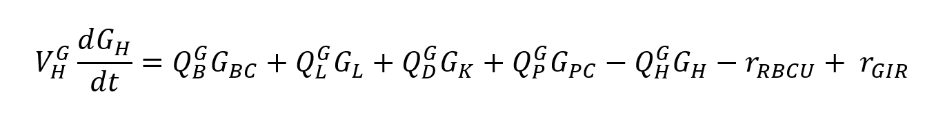 57

We set the target for our system to be 120 mg/dl of blood glucose. As can be observed in Figure 111 we have chosen to implement a glucose infusion of 44 grams over a period of just over two hours. The chosen waveform was derived from intravenous glucose tolerance test data provided by Vahidi and filtered using a low-pass filter to smooth the discrete values into a continuous waveform.

Figure 11: Disturbance waveform derived from discrete intravenous glucose tolerance test data. 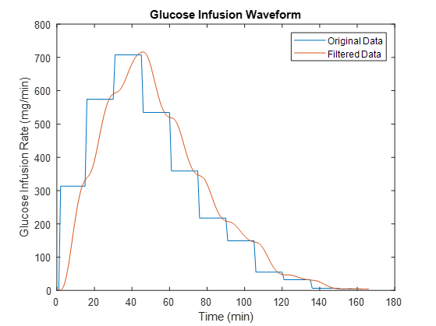

## Transfer Function Approximation

In order to tune a controller to control the nonlinear, Sorensen model-based, diseased state, plant, a transfer function was approximated using MATLAB’s *tfest* function. The data used to fit the transfer function was obtained by inputting a continuous insulin infusion rate of 1 mU/min into the system after it reached steady state.

The decision was made to keep the estimation as a second order approximation, even if the accuracy of the fit was compromised, in order to ensure a more stable response. Increasing it to a third order function may have created a better fit, but turning the controller would be more difficult. The second order transfer function approximation from *tfest* in pole-zero form is,

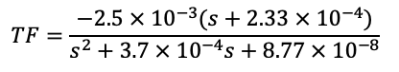 58

To test the transfer function approximation, an insulin infusion was given. Figure 12 shows the approximated transfer function blood glucose response and the plant’s blood glucose response. When tested with an insulin infusion, the transfer function approximation’s blood glucose response had an 85% fit to the plant’s blood glucose response. The 85% fit of the second order transfer function approximation was deemed good for its purpose of controller tuning.

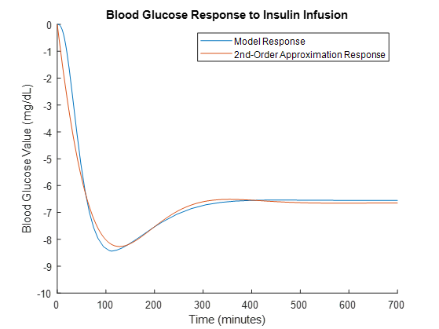

Figure 12: Comparison of the model response to the estimated transfer function response.

To test the stability of the of the approximated transfer function (Equation 58), a pole-zero plot was created (Figure 13). The pole-zero plot shows the two poles, the single zero, and that the closed loop system will remain stable as the gain increases, when using this transfer function to represent the plant. The plot predicts constant stability because of the negative one multiplier added to the error reading before it entered the controller (Figure 1). The discussion on that addition is found in the Control System Background section.

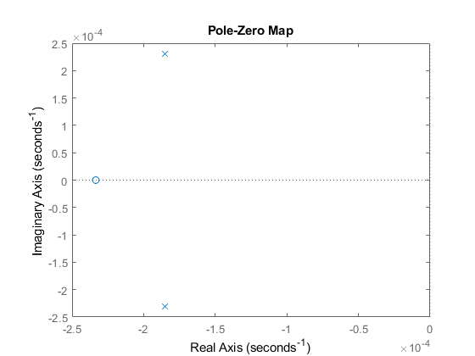

Figure 13: Pole zero plot of the second-order approximation transfer function for the plant.

With a stable approximated transfer function with a good percent fit to the plant, the controller could be tuned.

## Controller Creation and Tuning

Upon obtaining a transfer function that approximates the plant the next step was to choose a type of controller that properly controls the chosen transfer function, and later the entire system when the plant is reimplemented. The controller was chosen using Root Locus theory as well as estimating the proportional, integral and derivative portions of the controller. Figures 14 and 15 show the first attempt at the controller. The figures depict a root locus plot and step response for a simple proportional controller. The proportional value was 100. The step input into the system was 1mg/min of insulin. The Root Locus plot indicates that the poles of the system are relatively close to the real axis and located in the negative portion of the diagram. This is ideal as it indicates our system is stable. The step response is overdamped because it takes over eight minutes to reach 95 percent of the target value.

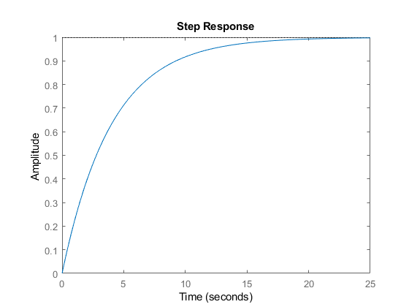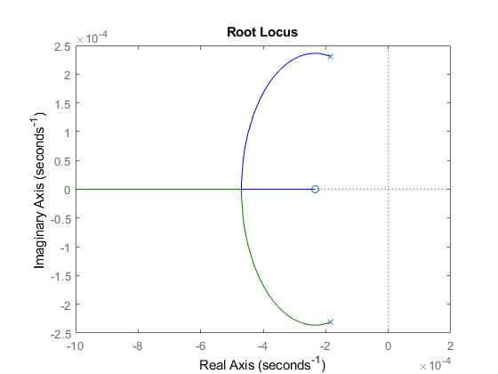

Figures 14 and 15: Step response and root locus of system under proportional control of 100.

The proposed controller was also tested using the glucose infusion waveform provided by Sorenson (Figure 16). Overall the response is desirable as the peak blood glucose value has been reduced when compared to an uncontrolled diseased system. That being said, the controller requires additional adjustment particularly when accounting for the overcompensation of the controller. As seen in the figure, blood glucose values crash to less than 50 mg/dL which is concerning considering blood glucose values below 70 mg/dL are considered dangerous.

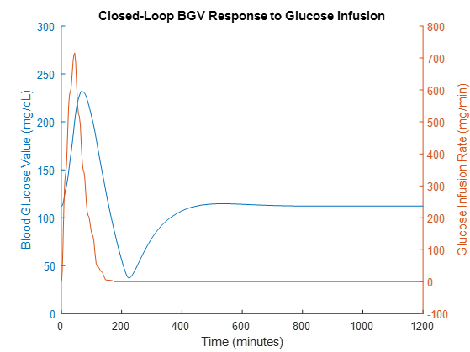

Figure 16: Response of system to glucose disturbance under proportional control of 100.

After seeing that a P controller could not properly control the system, the next step was to try a PI controller with proportional and integral components. The proportional gain was left at 100 and the integral gain was set to 10 (Figures 17 & 18).

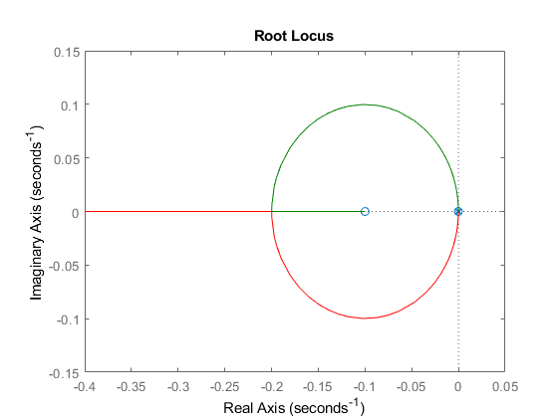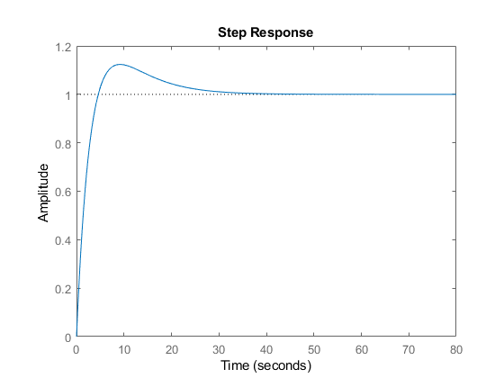

Figures 17 and 18: Step response and root locus plot of system under PI control with proportional gain of 100 and integral control of 10.

Figure 18 shows that the step response of the system became underdamped. An additional pole and zero appear near the origin of our root locus plot due to the integral component of the controller. Despite adding the integral component to the controller, the output of blood glucose in response to a glucose infusion was not better than using the original P controller, explained above. The output showed a more drastic overcorrection than the P controller did and showed blood glucose values below 50mg/dL. This is because the addition of the integral component to the controller increased the accuracy but not the speed of the system (Figure 19).

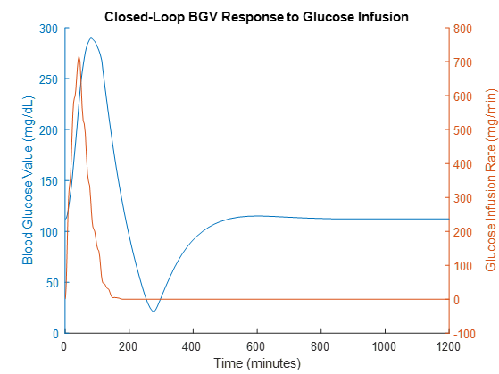

Figure 19: System response to blood glucose infusion under PI control.

Moving forward from the PI controller, it was recognized that blood glucose requires a “fast” controller. When a person consumes glucose, whether that be in the form of a meal or as an infusion, blood glucose values spike quickly. The first approach used for developing a controller to account for this was to increase the proportional gain of the system to be higher. When implemented, the system response did speed up, but also created large overshoots seen as “crashes” of blood glucose values. Next, the proportional gain was decreased, and the responses were viewed (Figures 20 & 21). This time the proportional gain was lowered to a more standard value of 1 and the integral component was lowered to .001. The step response and root locus plots are similar to the previous controller, specifically the difference in magnitude of the step response and root locus diagram.

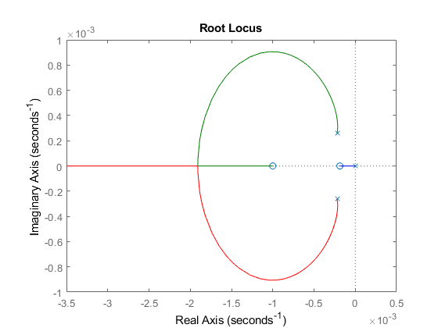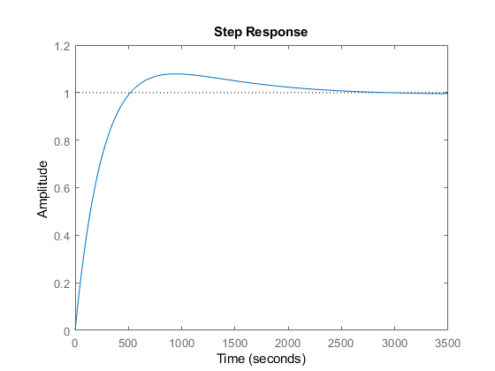

Figure 20 and 21: Root locus and step response of the system under PI control with proportional gain of 1 and integral gain of 0.001.

By reducing the proportional gain of the controller, the system now has less fluctuations in blood glucose value. This is particularly obvious when looking at the undershoot of our system. Figure 22 shows the system only having to correct itself to a value of 85 mg/dl, which is better than the corrections seen from other attempted controllers.

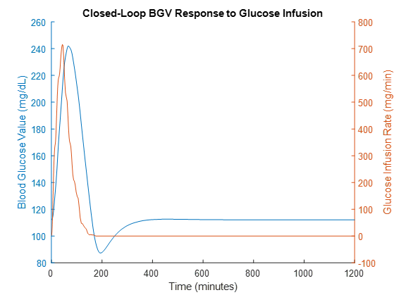

Figure 22: System response to blood glucose infusion under PI control with proportional gain of 1 and integral gain of 0.001.

Lowering the proportional gain of the controller was successful in controlling the undershoot of our system, but the overall speed of correction is still an issue. In order to account for speeding up the system, a derivative gain was added. Initially, a large derivative gain of 100 was chosen. By adding such a large derivative component to the controller it became sensitive to rates of error change in terms of increasing blood glucose, as opposed to the actual blood glucose error of the system itself. This is beneficial because it allows for large amounts of insulin to be inputed very quickly, which is similar to how a diabetic patient injects a bolus of insulin after a meal. The speed of our system can be visually interpreted using a root locus plot. Figures 23 and 24 show both and expanded and zoomed in version of the root locus for a PID controller.

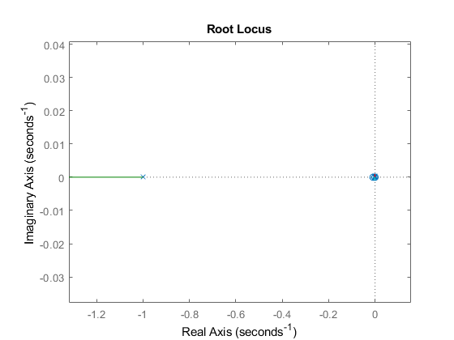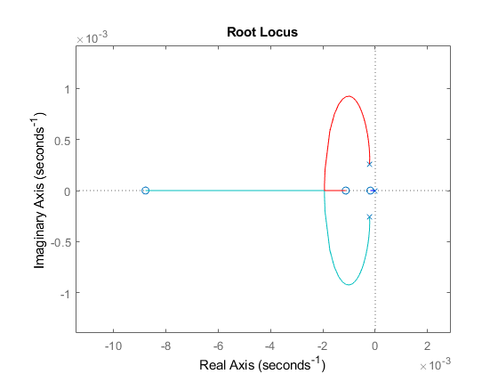

Figures 23 and 24: Root locus and step response of the system under PID control with proportional gain of 1, integral gain of 0.001, and derivative gain of 100.

Integration of the PID controller created a fast moving pole located at negative one. This is the component that drastically increases the speed of the system. It can be noted that zooming in on the root locus plot at the origin results in a diagram that is similar to the one displayed in Figure 20. The resulting output of using a PID controller with the discussed values is seen in Figure 25 below.

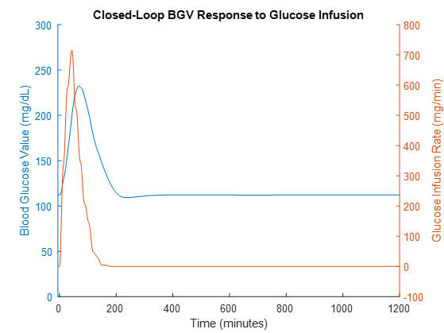

Figure 25: System response to blood glucose infusion under PID control with proportional gain of 1, integral gain of 0.001, and derivative gain of 100.

When observing the final response of the system using a PID controller some observations can be noted. The first is the absence of undershoot in the system and the second is the ability of the system to correct itself extremely fast. The system corrects itself to baseline in only 200 minutes which is twice as fast as the other attempted controllers. This is due to two components of our system. The first is the high derivative gain and the second is the addition of a switch statement integrated into the controller. As stated previously, increasing the derivative gain of the controller makes it more sensitive to rates of error change as opposed to the actual error of the system itself. The derivative gain of the controller is so sensitive that outputs of insulin were sometimes seen in regions where blood glucose was below the target value of 120 mg/dL. This occurred in regions of the system where blood glucose was increasing quickly but still below the target value of 120 mg/dL. The approach to solving this was the addition of a switch statement that stated when the read output was less than the target baseline blood glucose value, the insulin release from the pump would be 0 mg/dL. The switch statement solved the issue of overinputing insulin and also limited the fluctuations due to blood glucose changes which occur often in everyday life, that our controller is very sensitive too.

# System Characterization

Once the optimal controller was chosen, the 2nd-order plant approximation was replaced with the fully-implemented plant. The output of this system was characterized with a target of 120 mg/dL of glucose in the peripheral capillary space, and with various glucose disturbance waveforms.

## Disturbance Waveforms



Figure 26: IGTT data that was modified to be continuous and then used to create a disturbance in the plant to test the ability of the controller.

The first disturbance waveform was derived from intravenous glucose tolerance test (IGTT) data provided by Vahidi, as mentioned previously [A]. In this data, 44g of glucose is infused over 2 hours. Because the delivery rate was only sampled every 15 minutes in the original data, values were discrete. The sampling rate was increased and the data passed through a low-pass filter to obtain the continuous waveform in Figure 26.

To ensure our controller could account for additional types of waveforms we choose to validate the system with two other inputs that also assess the controller’s capabilities. The first is a step input of 200 mg/ml over 300 minutes and the second is a small infusion with a peak of just 47 mg/min also over a period of approximately 300 minutes. Both of the additional infusions can be seen in Figures 27 and 28 below.

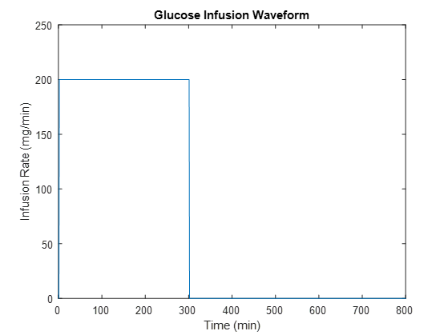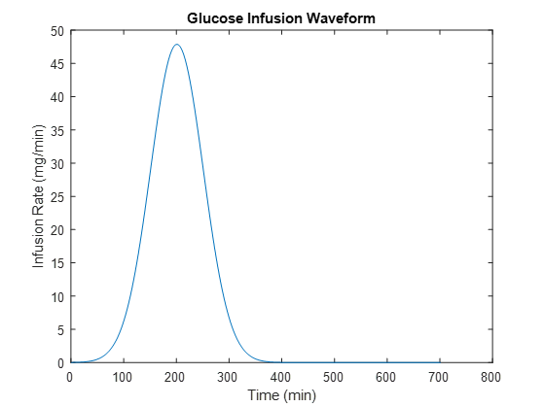

Figures 27 & 28: Glucose step input (200 mg/ml over 300 minutes) and glucose infusion (peak at 47 mg/mL over 300 minutes)

## System Response to IGTT Data

In response to a 44g infusion of glucose over approximately 2 hours, the healthy system reached a blood glucose value of approximately 265mg/mL (Figure 29). The uncontrolled diseased system reached a value of approximately 290mg/mL (Figure 29). With the implemented controller, the diseased system only reached a blood glucose value of approximately 230mg/mL (Figure 29). The decreased glucose spike in the controlled diseased system shows that more glucose was uptaken by cells in the time range than of the uncontrolled diseased system. This supports the ability of the controller to pump insulin into the plant to manage the glucose infusion. Along with looking at the glucose peaks resulting from the glucose infusion, it is also valuable to highlight the ability of the response to level out around 120mg/mL of glucose. The controlled diseased system was able to level out to just below 120 mg/mL approximately 200 minutes quicker than the uncontrolled diseased system was able to (Figure 29). Interestingly enough, the controlled diseased system also leveled out quicker than the healthy system. Being able to increase the speed the system can regulate to a normal resting blood sugar level is important because, in this situation, it decreases the drop in blood glucose level before leveling out. That drop can be thought of as a sugar crash after eating a large amount of sugar. Preventing the system from having a large drop as it is trying to level out is important and valuable when modeling blood glucose regulation.

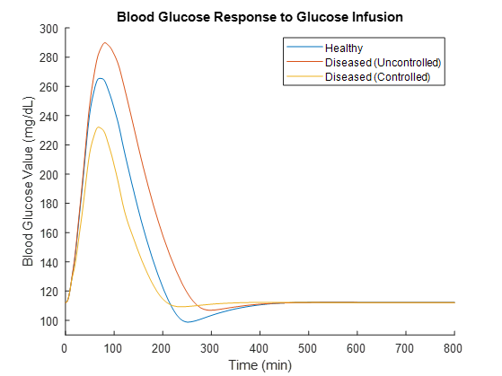

Figure 29: Blood glucose value resulting from a 44g glucose infusion.

Seeing how the blood glucose level in the periphery is impacted by the glucose infusion is a good first step to seeing the body’s response to the infusion. It is also important to see how the pancreas responds to the glucose infusion. Figure 30 compares the pancreatic insulin production rates between healthy, uncontrolled diseased, and controlled diseased states in response to the glucose infusion. In the healthy system, the production rate rises and settles to a constant rate the quickest. The uncontrolled diseased state takes longer to reach the maximum insulin production rate and to level out to a constant production rate, which is lower than in the healthy state. Figure 30 also shows that the controller was able to offload the pancreas, modeling a way to stop pancreatic burnout from occurring in Type II diabetic patients. Off loading is seen by the decrease in the insulin produced in the controlled diseased state compared to the uncontrolled diseased state. The uncontrolled diseased state produced 6.7U of insulin and the controlled diseased state produced 5.9U of insulin.

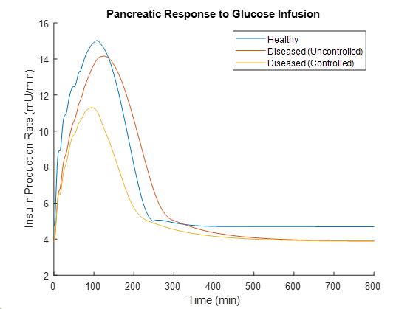

Figure 30: Pancreatic insulin production rate in response to a glucose infusion.

The final aspect that was deemed important to check after the 44g infusion of glucose was the insulin pump response to that glucose infusion. Figure 31 shows the increase in insulin delivery rate (mU/min), and it was calculated that the input to the plant to manage the infusion of glucose was 15U of insulin. The controller was able to respond to the glucose infusion quickly, resulting in the desired decrease of blood glucose value to the ideal value of 120 mg/dL.

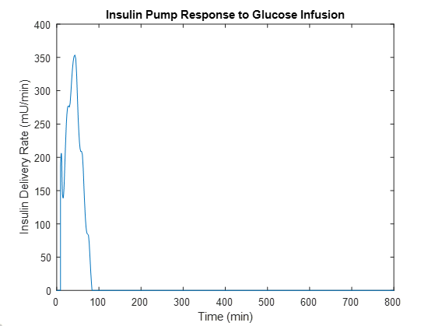

Figure 31: Insulin pump response to 44g glucose infusion.

## System Response to Square Wave

To continue on with validating the designed system, a step input of 200mg/min of glucose for 300 minutes was infused into the plant (Figure 32). The resulting blood glucose value, insulin production rate, and insulin delivery rate from the pump are reported below.



Figure 32: Glucose infusion step input of 200 mg/ml over 300 minutes.

The results from the square wave glucose infusion were comparable to those from the IGTT data (Figure 33). The uncontrolled diseased system had the highest resulting blood glucose value after the glucose infusion, followed by the healthy system. The controlled diseased system had the lowest resulting blood glucose value (mg/dL), and it was able to regulate itself to the target blood glucose value (120mg/dL) the quickest showing a system response quicker than that of the healthy system.

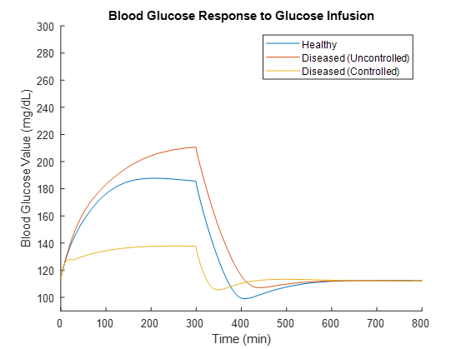

Figure 33: Blood glucose value resulting from a 200mg/mL step input of glucose.

Figure 34 shows the decrease in pancreatic insulin production rate by the controlled diseased system. The healthy system produces 8.2U of insulin over the time period shown, and the uncontrolled diseased system produces 7.5U of insulin in response to the square wave glucose infusion. The lower amount of insulin produced in the uncontrolled diseased state shows the inability of the body to secrete enough insulin to effectively manage the blood glucose level (Figure 33). The controlled diseased model resulted in 5.6U of total insulin produced, with a quicker return to basal value as compared to the uncontrolled and healthy system (Figure 34). That result supports that the controller was able to offload the pancreas, but ensure that blood glucose was effectively regulated (Figure 33). Showing the offloading of the pancreas is important when working to control the progression of Type II Diabetes, and can be further supported using Figure 34.

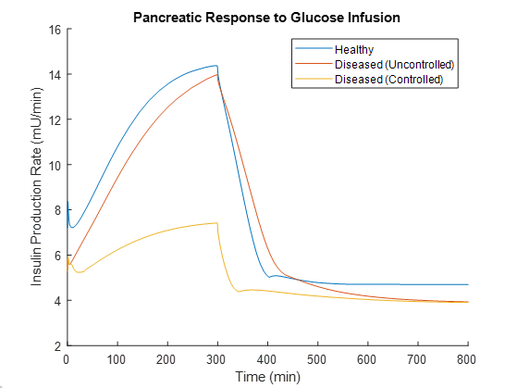

Figure 34: Pancreatic insulin production rate in response to 200mg/mL step input of glucose.

Figure 35 shows the quicker response that the controller had compared to the IGTT data induced insulin pump response (Figure 31). The maximum insulin delivery rate was reached before 10 minutes after the square wave input glucose infusion began, and then became steady at approximately 50 minutes. The delivery rate was then held constant until the glucose infusion stopped at 300min, where the insulin delivery rate from the pump stopped as well. This shows the success of the controller and the pump to deliver enough insulin to manage the blood glucose value throughout the test, and its ability to have the system controlled so well that no further modifications had to be made after the glucose infusion ended. Over the 300 minutes of glucose infusion, 4U of insulin were pumped into the system.

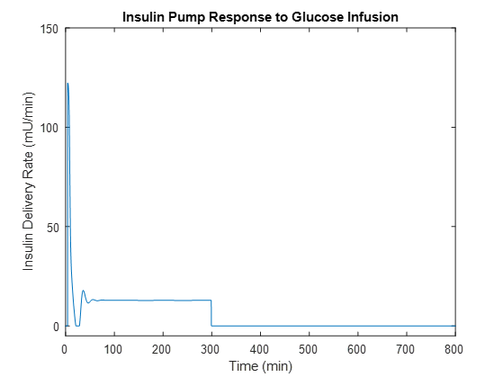

Figure 35: Insulin pump response to step input of 100mg/mL of glucose. The output is 0 after 300 minutes.

## System Response to Shallow Disturbance

The final test completed to validate the control system’s ability to regulate blood glucose value was done using a shallow disturbance that infused a total of 6g of glucose into the plant over 400 minutes (Figure 36). This waveform is used to show the need for the integral component in the PID controller. The small integral component allows for the controller to be able to respond to small changes in blood glucose, unique to this glucose infusion waveform. The resulting blood glucose value, insulin production rate in the pancreas, and insulin delivery rate from the pump are reported below.



Figure 36: Glucose infusion that peaks at 47 mg/mL over a time period of 300 minutes

Figure 37 shows the measured blood glucose value (mg/dL) in response to the glucose infusion once again showed the results seen from the IGTT data and square wave infusion (Figures 29 & 33). The uncontrolled diseased system showed the highest blood glucose value, followed by the controlled diseased system, and finally, the healthy system showing the lowest increase in blood glucose value over the infusion (Figure 37). It is valuable to note that the short delay around the 150min mark seen in the controlled diseased system represents the insulin pump turning on and beginning to input insulin to the plant via instructions from the controller.

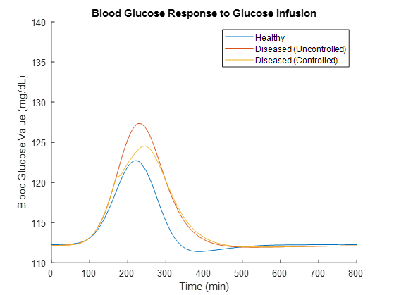

Figure 37: Blood glucose value response to glucose infusion of 47 mg/mL over a time period of 300 minutes

The insulin production rate in the pancreas shows the expected results as well. The pancreas produces the most insulin in the healthy system, followed by the uncontrolled diseased system, and then the controlled diseased system. Connecting the pancreatic insulin production with the regulation of blood glucose value supports the inability of the uncontrolled diseased system to utilize the insulin it is producing to effectively regulate the blood glucose value (Figures 37 & 38). Analysis of the controlled diseased system shows the ability of the controller to decrease the insulin coming from the pancreas (showing the offloading action to resist insulin burnout) while also effectively managing the blood glucose value in the system. The disturbance (decrease) in the insulin production rate for the controlled diseased system at the 150min mark represents the turning on of the insulin pump from the controller instructions.

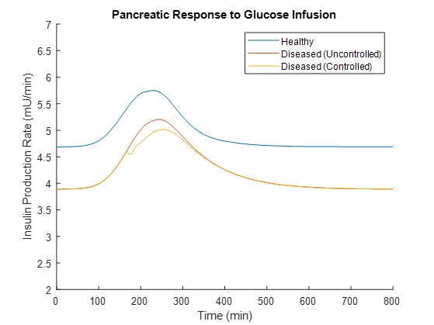

Figure 38: Pancreatic insulin production response to glucose infusion of 47 mg/mL over a time period of 300 minutes

The insulin delivery rate (mU/min) from the insulin pump is shown in Figure 39. At the 150min mark, where disturbances in pancreatic insulin production rate and blood glucose value are seen, there is a peak in insulin delivery rate from the pump. This peak supports the disturbances seen in the prior graphs, meaning the insulin pump is active and receiving necessary instructions from the controller needed to effectively manage the blood glucose values. Insulin delivery rate has smaller increases around 200min, showing the response to the highest rate of glucose infusion (Figures 36 & 39). After the 200min mark, the insulin infusion rate goes to 0 mU/min, meaning there was no need for extra insulin input to manage the decreasing rate of glucose infusion (Figures 36 & 39).

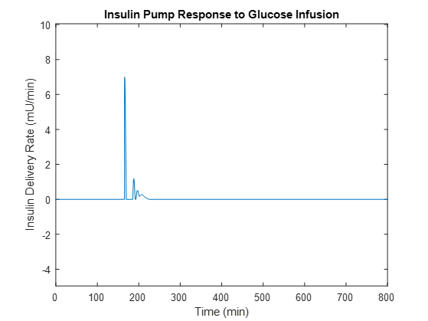

Figure 39: Insulin pump delivery rates in response to glucose infusion of 47 mg/mL over a time period of 300 minutes

# Conclusion

Based on the results from the System Characterizations completed on the control system, implementation of a controller was successful because of the controller’s ability to decrease pancreatic insulin production in a diabetic state, which prevented pancreatic burnout, and let the system rely on the artificial insulin source to supply additional insulin needed via instructions from the controller.

# Sources

[1] Center for Disease Control and Prevention, “Diabetes and Prediabetes Fast Facts,” U.S. Department of Health and Human Services. 2019.

[2] J. Berry. “Statistics and facts about type 2 diabetes,” Medical News Today, Apr. 2019.

[3] Röder, P. V., Wu, B., Liu, Y., & Han, W. “Pancreatic regulation of glucose homeostasis,” *Experimental & Molecular Medicine* *48*(3), 2016.

[4] National Institute of Diabetes and Digestive and Kidney Diseases. “Type 1 Diabetes”, National Institutes of Health, 2017.

[5] National Institute of Diabetes and Digestive and Kidney Diseases. “Type 2 Diabetes”, National Institutes of Health, 2017.

[6] K. Yoshida, ‘mm23- Control Notes’, IUPUI, 2019.

[7] Sorensen, JT. “A physiologic model of glucose metabolism in man and its use to design and assess improved insulin therapies for diabetes,” Ph.D dissertation, Chem. Eng. Dept, MIT, Boston, 1985. Accessed on: Dec. 15, 2019. Available: <http://www.cs.cmu.edu/~./dmilam/files/sorensen_thesis.pdf>

[8] Vahidi, O. “Dynamic modeling of glucose metabolism for the assessment of type II diabetes mellitus,” Ph.D dissertation, Chem. Eng. and Biological Eng. Dept, Univ. British Columbia, Vancouver, 2013. Accessed on: Dec. 15, 2019. Available: <https://pdfs.semanticscholar.org/1987/4c288c90d4711c48cd85e1349e43fc18c288.pdf>

[9] MathWorks, “Mathematics: Numerical integration and differential equations: Ordinary differential equations: ode45,” MATLAB Documentation. 2019. Available: <https://www.mathworks.com/help/matlab/ref/ode45.html>

[10] MathWorks Support Team, “What are algebraic loops in Simulink and how do I solve them?” MATLAB Answers. 2013. Available: <https://www.mathworks.com/matlabcentral/answers/95310-what-are-algebraic-loops-in-simulink-and-how-do-i-solve-them>

[11] MathWorks, “Simulation: Configure simulation conditions: Algebraic loop concepts,” Simulink Documentation. 2019. Available: <https://www.mathworks.com/help/simulink/ug/algebraic-loops.html>

[12] Aleppo, G. “Insulin pump overview,” EndocrineWeb, Remedy Health Media. 2019. Available: <https://www.endocrineweb.com/guides/insulin/insulin-pump-overview>

# Appendix

## Appendix A: Constants

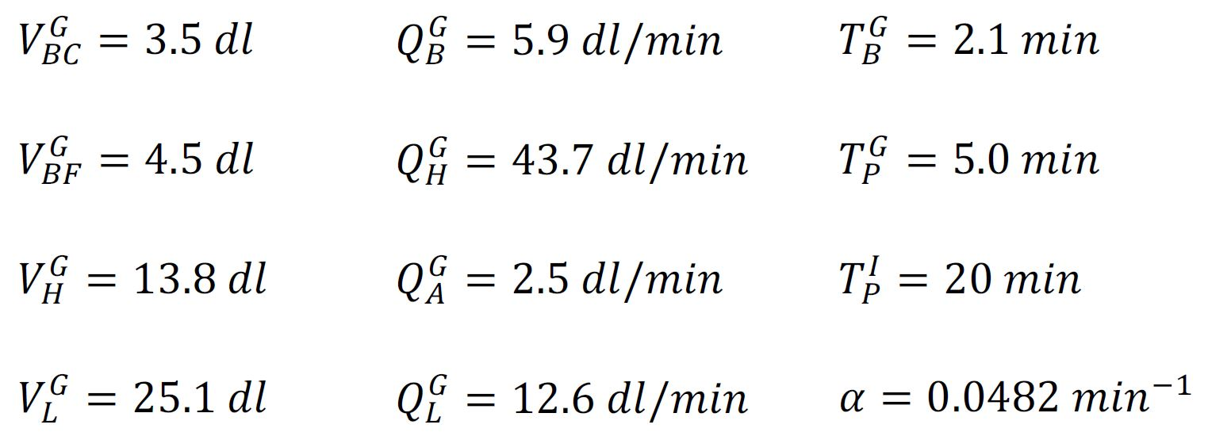

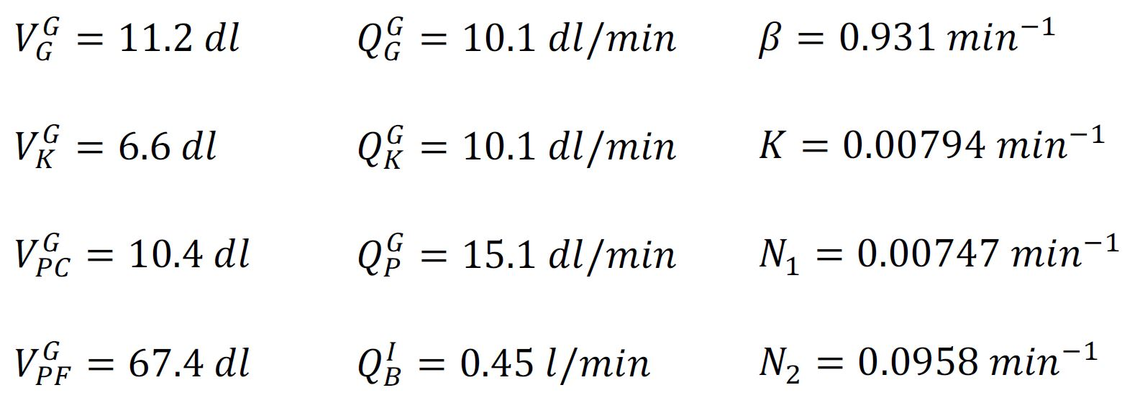

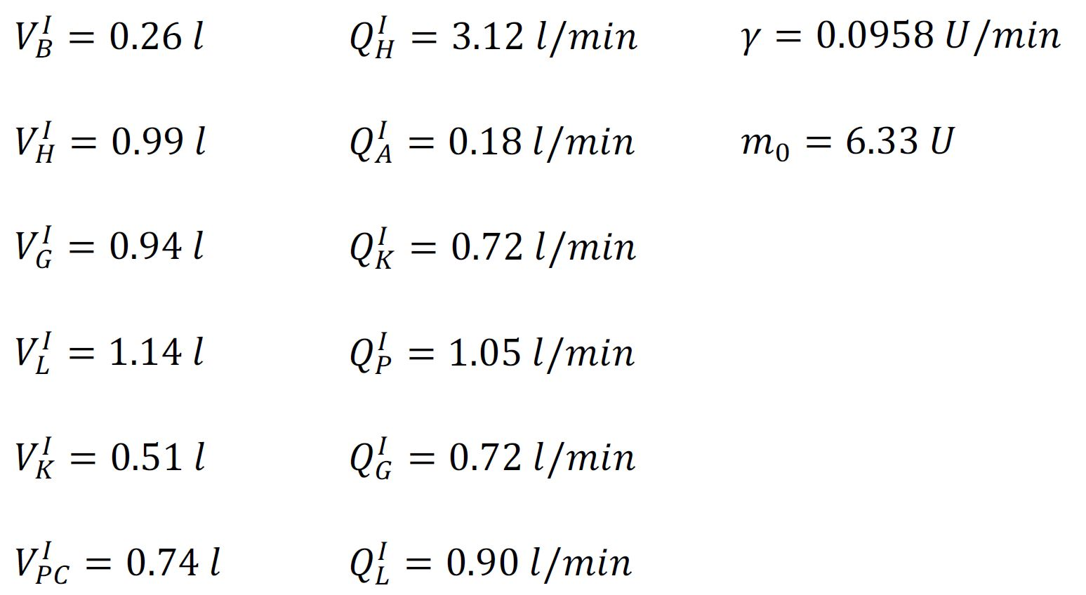

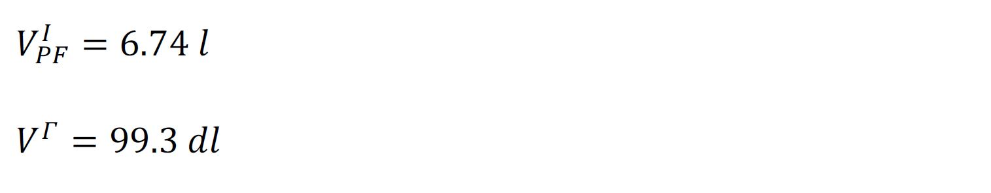

## Appendix B: Code

The entire project, including Simulink and MATLAB code is publically available at <https://github.com/rsurridg/sorensen_model_full>

The model (GlucagonGlucoseIntegration.slx) is currently configured to run in closed loop control with a PID controller. Run Constants.m and Basal_Conditions.m prior to running the model. Ensure that all “models” subfolders are on the MATLAB path. Some MATLAB scripts are repeated below for quick reference.

### Step Input Characterization and Transfer Function Fitting

close all;

clc;

length_recording = 1500;

time_input = 800;

ind = sum(out.Insulin_Input.time<time_input);

time = out.Insulin_Input.time(ind:end)/60 - time_input/60;

input = out.Insulin_Input.signals.values(ind:end);

figure(1);

hold on;

signal = out.Glucose_PC.signals.values(ind:end);

signal = signal;

signal = signal - signal(1);

ylabel('Blood Glucose Value (mg/dL)');

plot(time*60, signal);

title('Blood Glucose Response to Insulin Infusion');

xlabel('Time (minutes)');

%% downsample algorithm

n = length_recording - time_input;

signalDS = zeros(1,n);

inputDS = zeros(1,n);

time_min = time.*60;

for i = 1:n

signalDS(i) = signal(sum(time_min<i));

inputDS(i) = input(sum(time_min<i));

end

data = iddata(signalDS', inputDS', 60);

sys = tfest(data, 2);

[Y,T] = step(sys,0:60:n*60); % every 60 seconds up to 700 minutes

plot(T/60, Y); % plot minutes on x axis

legend('Model Response', '2nd-Order Approximation Response');

axis([0 700 -10 0])

### Basal Values (From Vahidi)

% Used

GPC_B = 153.4; %90

% rates

rPGU = 35; % peripheral blood glucose uptake (baseline value)

rBGU = 70; % brain glucose uptake

rGGU = 20; % gut glucose uptake

rHGP = 155; % hepatic glucose production (not sure where this value comes from, its 35 on p25 of paper)

rHGU = 20; % hepatic glucose uptake (basal)

% fluxes

QGP = 15.1; %

QGA = 2.5; %

QGB = 5.9; %

QGG = 10.1; %

QGL = 12.6; %

% not sure what these guys are

VBT = 4.5; % volume, brain interstitial fluid, for glucose

VPT = 63; % volume, peripheral tissues, for glucose (67.4 on p33)

% time constants

TGP = 5; % time constant, peripheral glucose

TB = 2.1; % time constant, brain glucose

% baseline glucose values

GHC_B = GPC_B+rPGU/QGP;

GKC_B = GHC_B;

GBC_B = GHC_B-rBGU/QGB;

GSC_B = GHC_B-rGGU/QGG;

GLC_B = (QGA*GHC_B+QGG*GSC_B+rHGP-rHGU)/QGL;

GBT_B = GBC_B-rBGU*TB/VBT;

GPT_B = GPC_B-rBGU*TGP/VPT;

% baseline insulin values

IPC_B = 5.9;

% multipliers for rate constants (3.39, 3.40, 3.41)

FPIC = 0.15;

FKIC = 0.3;

FLIC = 0.4;

% insulin fluxes (consistent with paper)

QIP = 1.05;

QIH = 3.12;

QIB = 0.45;

QIK = 0.72;

QIL = 0.9;

QIG = 0.72;

QIA = 0.18;

% time constants

TIP = 20; % time constant, peripheral insulin

VPT = 6.3; % reassignment. volume of peripheral tissues, for insulin (6.74 on p33)

Q0 = 6.33; % starting mass of labile insulin

% insulin baseline values

IHC_B = IPC_B/(1-FPIC);

IKC_B = IHC_B*(1-FKIC);

IBC_B = IHC_B;

ISC_B = IHC_B;

IPT_B = IPC_B-(QIP*TIP*(IHC_B-IPC_B)/VPT);

ILC_B = (QIH*IHC_B-QIB*IHC_B-QIK*IKC_B-QIP*IPC_B)/QIL;

% pancreatic insulin release

rPIR_B = QIL*ILC_B/(1-FLIC)-QIG*ISC_B-QIA*IHC_B;

### Constant Values (From Vahidi)

%insulin

V_i_B=.26;

V_i_H=.99;

V_i_G=.94;

V_i_L=1.14;

V_i_K=.51;

V_i_PC=0.74;

V_i_PF=6.74;

V_gamma=99.3;

Q_i_B=.45;

Q_i_H=3.12;

Q_i_A=.18;

Q_i_K=.72;

Q_i_P=1.05;

Q_i_G=0.72;

Q_i_L=.90;

T_i_P=20;

%Glucose

Q_bG=5.9;

V_gBF = 4.5;

V_gBC = 3.5;

T_gB=2.1;

GAMMA_B = 1; % ASSUMPTION

V_gK=6.6;

Q_gK=10.1;

T_gP=5.0;

Q_gP=15.1;

V_gPC=10.4;

V_gPF=67.4;

V_gG=11.2;

Q_gG=10.1;

Q_gH=43.7;

V_gH=13.8;

Q_gB=5.9;

Q_gL=12.6;

V_gL=25.1;

Q_gA=2.5;

r_BGU = 70;

r_RBCU = 10;

r_GGU = 20;

r_bPGU = 35;

r_bHGP = 35;

r_bHGU = 20;

r_bPGamR = 9.1;

%% Pancreas

a = 0.0482;

b = 0.9310;

K = 0.00794;

K2 = 100*K;

lambda = 0.0958;

m0 = 6.33;

%% DIABETIC

N1 = 0.00595;

N2 = 0.0467;

M_iPGU_aD = 2.551;

M_iPGU_bD = 1.66;

M_iPGU_cD = 0.69;

M_iPGU_dD = 3.454;

M_iinfHGP_aD = 1.173;

M_iinfHGP_bD = 1.073;

M_iinfHGP_cD = 0.993;

M_iinfHGP_dD = 1.164;

M_iinfHGU_aD = 0.662;

M_iinfHGU_bD = 0.731;

M_iinfHGU_cD = 0.985;

M_iinfHGU_dD = 0.493;

M_gHGU_aD = 1.855;

M_gHGU_bD = 1.85;

M_gHGU_cD = 2.047;

M_gHGU_dD = 1.244;

M_gPGU_aD = 0.897;

M_gPGU_bD = 0.103;

%% HEALTHY

% N1 = 0.00747;

% N2 = 0.0958;

%

% M_iPGU_aD = 7.03;

% M_iPGU_bD = 6.52;

% M_iPGU_cD = 0.338;

% M_iPGU_dD = 5.82;

%

% M_iinfHGP_aD = 1.21;

% M_iinfHGP_bD = 1.14;

% M_iinfHGP_cD = 1.66;

% M_iinfHGP_dD = 0.89;

%

% M_iinfHGU_aD = 0;

% M_iinfHGU_bD = 2.0;

% M_iinfHGU_cD = 0.55;

% M_iinfHGU_dD = 0;

%

% M_gHGU_aD = 5.66;

% M_gHGU_bD = 5.66;

% M_gHGU_cD = 2.44;

% M_gHGU_dD = 1.48;

%

% M_gPGU_aD = 1;

% M_gPGU_bD = 0;